**Questions 4**

A company has defined two RAML fragments, Book Data Type and Book Example to be used in APIs.

What would be valid RAML to use these fragments ?

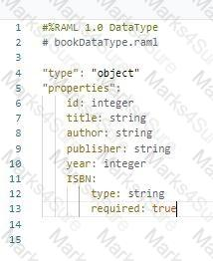

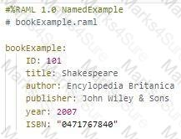

Options:

A.

1. #%RAML 1.0

2. title: Books

3. types:

4. Book: ABC/Examples/bookDataType.raml

5. /books:

6. post:

7. body:

8. application/json:

9. type: Book

10. examples:

11. input: ABC/Examples/bookExample.raml

12. responses:

13. 201:

14. body:

15. application/json:

16. example:

17. message: Book added

B.

1.#%RAML 1.0

2.title: Books

3.Book: !include bookDataType.raml

4./books:

5. post:

6. body:

7. application/json:

8. type: Book

9. examples:

10. input: !include bookExample.raml

11. responses:

12. 201:

13. body:

14. application/json:

15. example:

16. message: Book added

C.

1.#%RAML 1.0

2.title: Books

3.Book: bookDataType.raml

4./books:

5. post:

6. body:

7. application/json:

8. type: Book

9. examples:

10. input: bookExample.raml

11. responses:

12. 201:

13. body:

14. application/json:

15. example:

16. message: Book added

D.

1.#%RAML 1.0

2.title: Books

3.Book: bookDataType.raml

4./books:

5. post:

6. body:

7. application/json:

8. type: Book

9. examples:

10. input: bookExample.raml

11. responses:

12. 201:

13. body:

14. application/json:

15. example:

16. message: Book added

**ANS: Option D**

**Questions**

A Mule project contains a MySQL Database dependency. The project is exported from Anypoint Studio so it can be deployed to CloudHub.

What export options create the smallest deployable archive that will successfully deploy to CloudHub?

What export option create their smallest deployable archive that will successfully deploy to CloudHub?

A)

https://www.marks4sure.com/img/media/MuleSoft/MCD-Level-1/11.0/83e161ca-8d7e-4212-ac8e-e9d370603af6.png

B)

https://www.marks4sure.com/img/media/MuleSoft/MCD-Level-1/11.0/60fbd665-a232-4f2f-9ecf-0dcc68e4903d.png

C)

https://www.marks4sure.com/img/media/MuleSoft/MCD-Level-1/11.0/408ca5cc-4e92-4fdb-befb-66b35276a06e.png

D)

https://www.marks4sure.com/img/media/MuleSoft/MCD-Level-1/11.0/1a5019a8-2de9-44ee-8495-38e2bb899cc5.png

Options:

A.

Option A

B.

Option B

C.

Option C

D.

Option D

**ANS: option B**

**Questions**

According to Semantic Versioning, which version would you change for incompatible API changes?

Options:

A.

No change

B.

MINOR

C.

MAJOR

D.

PATCH

**ANS: option C**

**Questions**

Refer to the exhibit.

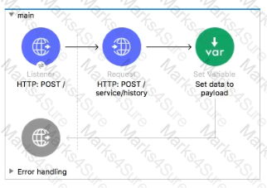

What can be added to the flow to persist data across different flow executions?

Options:

A.

Key/value pairs in the ObjectStore

B.

Properties of the Mule runtime flow object

C.

properties of the Mule runtime app object

D.

session variables

**ANS: option A**

**Questions**

Refer to the exhibit.

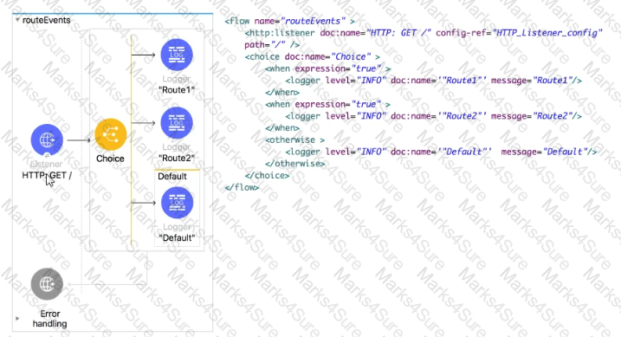

All three of the condition for the Choice router are true. What log messages are written?

Options:

A.

Route 1

B.

Route2

C.

Route1, Route2

D.

Route1, Route2, Default

**ANS: option A**

**Questions**

As a part of project requirement , you want to build an API for a legacy client. Legacy client can only consume SOAP webservices. Which type the interface documentation can be prepared to meet the requirement?

Options:

A.

RAML file to define SOAP services

B.

WSDL file

C.

JSON file

D.

plain text file documenting API's

**ANS: option B**

**Questions**

What is the trait name you would use for specifying client credentials in RAML?

Options:

A.

headers

B.

client-id

C.

client-id-required

D.

cannot be specified in RAML

**ANS: option C**

**Questions**

Refer to the exhibits.

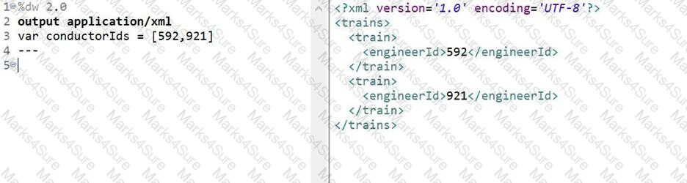

What DataWeave expression transforms the conductorIds array to the XML output?

Options:

A.

1. 1. trains:

2. 2. conductorIds map ((engId, index) ->

3. 3. train: {

4. 4. engineerId: engId

5. 5. }

6. 6. )

B.

1. 1. { trains:

2. 2.

3. 3. conductorIds map ((engId, index) ->

4. 4. train: {

5. 5. engineerId: engId

6. 6. }

7. 7. )

8. 8. }

C.

1. 1. trains:

2. 2. {(

3. 3. conductorIds map ((engId, index) ->

4. 4. train: {

5. 5. engineerId: engId

6. 6. }

7. 7. )

8. 8. )}

D.

1. 1. {( trains:

2. 2.

3. 3. conductorIds map ((engId, index) ->

4. 4. train: {

5. 5. engineerId: engId

6. 6. }

7. 7. )

8. 8. )}

**ANS: option C**

**Questions**

Refer to the exhibit.

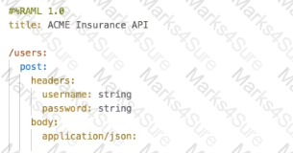

What is the correct way to create a user?

A)

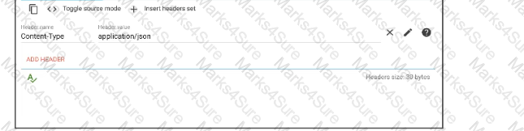

B)

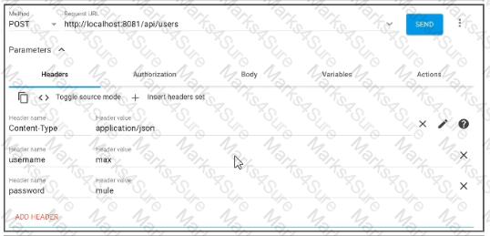

C)

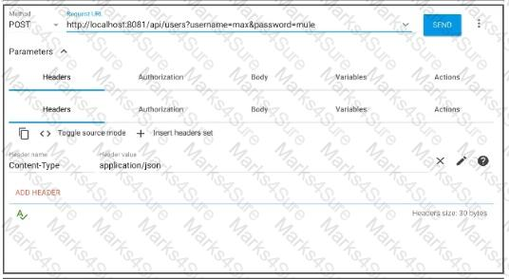

D)

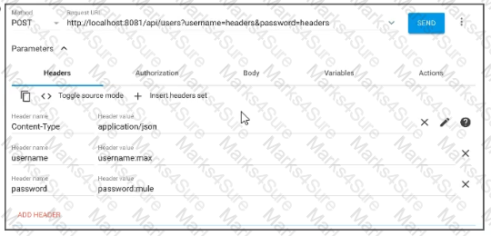

Options:

A.

Option A

B.

Option B

C.

Option C

D.

Option D

**ANS: option B**

**Questions**

What is the correct way to format the decimal 200.1234 as a string to two decimal places?

Options:

A.

200.1234 as string as format: ".0#"

B.

200.1234 as String {format: ".0#"}

C.

200.1234 as String as format: ".0#"

D.

200.1234 as string {format: ".0#"}

**ANS: option B**

**Questions**

How are multiple conditions used in a Choice router to route events?

Options:

A.

To route the same event to the matched route of EVERY true condition

B.

To find the FIRST true condition, then distribute the event to the ONE matched route.

C.

None of these

D.

To find the FIRST true condition, then route the same event to the matched route and ALL FOLLOWING routes

**ANS: option B**

**Questions**

What should this endpoint return? http://dev.acme.com/api/patients?name=John &surname=Bell

Options:

A.

Patient with name as John

B.

Patient with surname as bell

C.

Patients with either name as John or surname as Bell

D.

Patients with name as John and surname as Bell

**ANS: option D**

**Questions**

What is the output of Dataweave Map operator?

Options:

A.

Map

B.

Object

C.

String

D.

Array

**ANS: option D**

**Questions**

How we can scale deployed Mule application vertically on cloudhub?

Options:

A.

Changing worker size

B.

Adding multiple workers

C.

Mule applications can be scaled only horizontally

D.

Option 1 and 2 both can be used

**ANS: option A**

**Questions**

Refer to the exhibit.

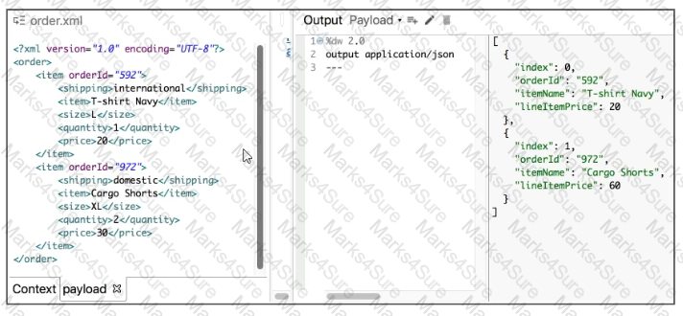

What Database expression transforms the input to the output?

A)

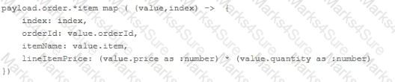

B)

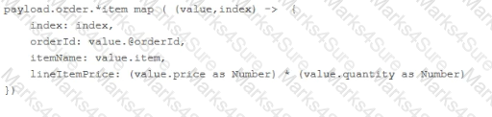

C)

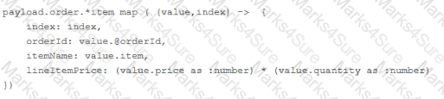

D)

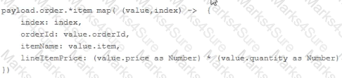

Options:

A.

Option A

B.

Option B

C.

Option C

D.

Option D

**ANS: option B**

**Questions**

A web client submits a request to http://localhost:8081/books/0471767840. The value "0471767840" is captured by a Set Variable transformer to a variable named booklSBN.

What is the DataWeave expression to access booklSBN later in the flow?

Options:

A.

booklSBN

B.

attributes.booklSBN

C.

flowVars.booklSBN

D.

vars. BooklSBN

**ANS: option D**

**Questions**

Refer to the exhibits.

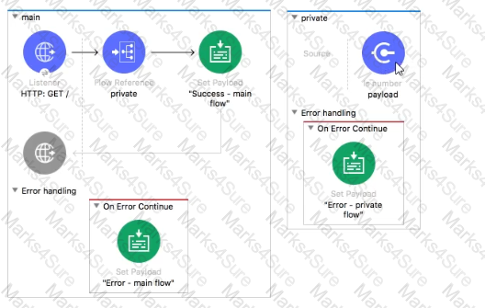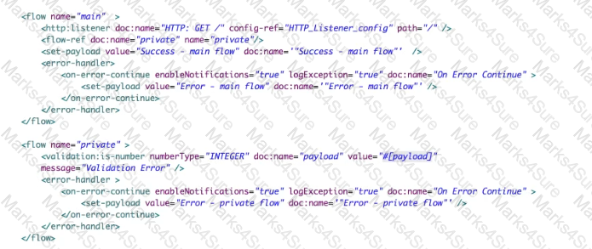

The Validation component in the private flow throws an error. What response message is returned to a client request to the main flow's HTTP Listener?

Options:

A.

Error - private flow

B.

Error - main flow

C.

Success - main flow

D.

Validation Error

**ANS: option B**

**Questions**

A function named newProdCode needs to be defined that accepts two input parameters, an integer value for itemID and a string value for productCategory, and returns a new product code.

What is the correct DataWeave code to define the newProdCode function?

Options:

A.

fun newProdCode{itemID: Number, productCategory: String) —> "PC-" ++ productCategory ++ (itemID as String)

B.

fun newProdCode(itemID: Number, productCategory: String) = "PC-" ++ productCategory ++ (itemID as String)

C.

function newProdCode(itemID: Number, productCategory: String) =

"PC-" ++ productCategory ++ (itemID as String)

D.

var newProdCode(itemID: Number, productCategory: String) ->

"PC-" ++ productCategory ++ (itemID as String)

**ANS: option B**

**Questions**

Refer to the exhibits.

Larger image

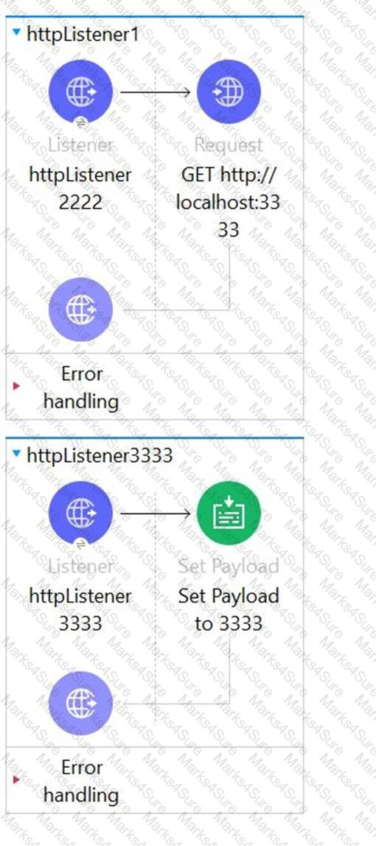

Larger image

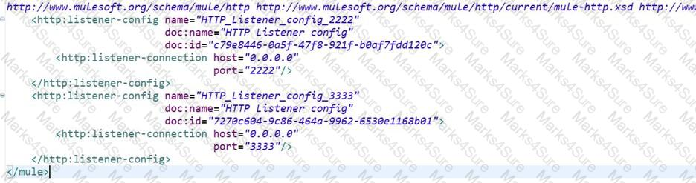

Larger image

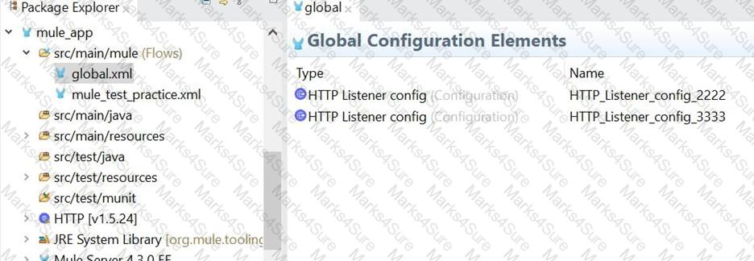

The Mule application configures and uses two HTTP Listener global configuration elements.

Mule application is run in Anypoint Studio.

If the mule application starts correctly, what URI and port numbers can receive web client requests? If the mule applications fails to start , what is the reason for the failure?

Options:

A.

The mule application fails to start

There is URL path conflict because both HTTP Listeners are configured with same path

B.

The mule application start successfully

Web client requests can only be received at URI on port 2222 but not on port 3333

C.

The mule application fails to start because of the port binding conflict as HTTP request also use same port i.e. 3333

D.

The mule application start successfully

Web client requests can be received at URI on port 2222 and on port 3333.

**ANS: option D**

**Questions**

As a part of requirement , application property defined below needs to be accessed as dataweave expression. What is the correct expression to map it to port value?

Options:

A.

{ port : p('db.port')}

B.

{ port : {db:port}}

C.

{ port : p['db.port']}

D.

Application property cannot be accessed in Dataweave

**ANS: option A**